**Answer 1:**

Code:

**#include <stdio.h>**

**#include <time.h>**

**#include <math.h>**

**int main(){**

**int i, j, k, l, alg;**

**printf("Input the test type: ");**

**scanf("%d", &l);**

**#include <time.h>**

**clock_t start, end;**

**double cpu_time_used;**

**start = clock();**

**switch(l)**

**{**

**case 1:**

**for(i=2; i<=pow(i,7); i++)**

**{**

**k=0;**

**for(j=1; j<=i-1; j++)**

**{**

**alg=i%j;**

**if(alg==0)**

**{**

**k++;**

**}**

**}**

**if(k==1)**

**{**

**printf("%d\n", i);**

**}**

**}**

**break;**

**case 2:**

**for(i=2; i<=pow(i,7); i++)**

**{**

**k=0;**

**for(j=1; j<=i/2; j++)**

**{**

**alg=i%j;**

**if(alg==0)**

**{**

**k++;**

**}**

**}**

**if(k==1)**

**{**

**printf("%d\n", i);**

**}**

**}**

**break;**

**case 3:**

**for(i=2; i<=pow(i,7); i++)**

**{**

**k=0;**

**for(j=1; j<=sqrt(i); j++)**

**{**

**alg=i%j;**

**if(alg==0)**

**{**

**k++;**

**}**

**}**

**if(k==1)**

**{**

**printf("%d\n", i);**

**}**

**}**

**}**

**end = clock();**

**cpu_time_used = ((double) (end - start)) / CLOCKS_PER_SEC;**

**printf("Time takes in %.3f", cpu_time_used);**

**}**

Output:

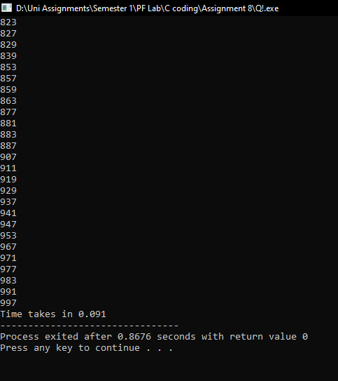

After doing all the 3 test, I observed test 1 was one of the quickest as less calculations were required to print 1000 prime numbers.

**Answer 2:**

**#include <stdio.h>**

**int main()**

**{**

**int month, day, i, j;**

**printf("Input the month: ");**

**scanf("%d", &month);**

**printf("Input the day: ");**

**scanf("%d", &day);**

**for(i=0; i<=0; i++)**

**{**

**switch(month)**

**{**

**case 1:**

**printf("\tJanuary\n\nMonday Tuesday Wednesday Thursday Friday Saturday Sunday\n");**

**switch(day)**

**{**

**case 1:**

**for(i=1; i<=31; i++)**

**{**

**printf("%5d ", i);**

**if(i==7 || i==14 || i==21||i==28)**

**{**

**printf("\n");**

**}**

**}**

**break;**

**case 2:**

**for(i=1; i<=31; i++)**

**{**

**if(i==1)**

**{**

**printf("\t ");**

**}**

**printf("%5d ", i);**

**if(i==6 || i==12 || i==18||i==24)**

**{**

**printf("\n");**

**}**

**}**

**break;**

**case 3:**

**for(i=1; i<=31; i++)**

**{**

**if(i==1)**

**{**

**printf("\t\t ");**

**}**

**printf("%5d ", i);**

**if(i==5 || i==12 || i==19||i==26)**

**{**

**printf("\n");**

**}**

**}**

**break;**

**case 4:**

**for(i=1; i<=31; i++)**

**{**

**if(i==1)**

**{**

**printf("\t\t\t ");**

**}**

**printf("%5d ", i);**

**if(i==4 || i==11 || i==18||i==25)**

**{**

**printf("\n");**

**}**

**}**

**break;**

**case 5:**

**for(i=1; i<=31; i++)**

**{**

**if(i==1)**

**{**

**printf("\t\t\t\t ");**

**}**

**printf("%5d ", i);**

**if(i==3 || i==10 || i==17||i==24)**

**{**

**printf("\n");**

**}**

**}**

**break;**

**case 6:**

**for(i=1; i<=31; i++)**

**{**

**if(i==1)**

**{**

**printf("\t\t\t\t\t ");**

**}**

**printf("%5d ", i);**

**if(i==2 || i==9 || i==16||i==23||i==30)**

**{**

**printf("\n");**

**}**

**}**

**break;**

**case 7:**

**for(i=1; i<=31; i++)**

**{**

**if(i==1)**

**{**

**printf("\t\t\t\t\t\t ");**

**}**

**printf("%5d ", i);**

**if(i==1 || i==8 || i==15||i==22 || i==29)**

**{**

**printf("\n");**

**}**

**}**

**break;**

**}**

**break;**

**case 2:**

**printf("\tFebruary\n\nMonday Tuesday Wednesday Thursday Friday Saturday Sunday\n");**

**switch(day)**

**{**

**case 1:**

**for(i=1; i<=28; i++)**

**{**

**printf("%5d ", i);**

**if(i==7 || i==14 || i==21||i==28)**

**{**

**printf("\n");**

**}**

**}**

**break;**

**case 2:**

**for(i=1; i<=28; i++)**

**{**

**if(i==1)**

**{**

**printf("\t ");**

**}**

**printf("%5d ", i);**

**if(i==6 || i==12 || i==18||i==24)**

**{**

**printf("\n");**

**}**

**}**

**break;**

**case 3:**

**for(i=1; i<=28; i++)**

**{**

**if(i==1)**

**{**

**printf("\t\t ");**

**}**

**printf("%5d ", i);**

**if(i==5 || i==12 || i==19||i==26)**

**{**

**printf("\n");**

**}**

**}**

**break;**

**case 4:**

**for(i=1; i<=28; i++)**

**{**

**if(i==1)**

**{**

**printf("\t\t\t ");**

**}**

**printf("%5d ", i);**

**if(i==4 || i==11 || i==18||i==25)**

**{**

**printf("\n");**

**}**

**}**

**break;**

**case 5:**

**for(i=1; i<=28; i++)**

**{**

**if(i==1)**

**{**

**printf("\t\t\t\t ");**

**}**

**printf("%5d ", i);**

**if(i==3 || i==10 || i==17||i==24)**

**{**

**printf("\n");**

**}**

**}**

**break;**

**case 6:**

**for(i=1; i<=28; i++)**

**{**

**if(i==1)**

**{**

**printf("\t\t\t\t\t ");**

**}**

**printf("%5d ", i);**

**if(i==2 || i==9 || i==16||i==23||i==30)**

**{**

**printf("\n");**

**}**

**}**

**break;**

**case 7:**

**for(i=1; i<=28; i++)**

**{**

**if(i==1)**

**{**

**printf("\t\t\t\t\t\t ");**

**}**

**printf("%5d ", i);**

**if(i==1 || i==8 || i==15||i==22 || i==29)**

**{**

**printf("\n");**

**}**

**}**

**break;**

**}**

**break;**

**case 3:**

**printf("\tMarch\n\nMonday Tuesday Wednesday Thursday Friday Saturday Sunday\n");**

**switch(day)**

**{**

**case 1:**

**for(i=1; i<=31; i++)**

**{**

**printf("%5d ", i);**

**if(i==7 || i==14 || i==21||i==28)**

**{**

**printf("\n");**

**}**

**}**

**break;**

**case 2:**

**for(i=1; i<=31; i++)**

**{**

**if(i==1)**

**{**

**printf("\t ");**

**}**

**printf("%5d ", i);**

**if(i==6 || i==12 || i==18||i==24)**

**{**

**printf("\n");**

**}**

**}**

**break;**

**case 3:**

**for(i=1; i<=31; i++)**

**{**

**if(i==1)**

**{**

**printf("\t\t ");**

**}**

**printf("%5d ", i);**

**if(i==5 || i==12 || i==19||i==26)**

**{**

**printf("\n");**

**}**

**}**

**break;**

**case 4:**

**for(i=1; i<=31; i++)**

**{**

**if(i==1)**

**{**

**printf("\t\t\t ");**

**}**

**printf("%5d ", i);**

**if(i==4 || i==11 || i==18||i==25)**

**{**

**printf("\n");**

**}**

**}**

**break;**

**case 5:**

**for(i=1; i<=31; i++)**

**{**

**if(i==1)**

**{**

**printf("\t\t\t\t ");**

**}**

**printf("%5d ", i);**

**if(i==3 || i==10 || i==17||i==24)**

**{**

**printf("\n");**

**}**

**}**

**break;**

**case 6:**

**for(i=1; i<=31; i++)**

**{**

**if(i==1)**

**{**

**printf("\t\t\t\t\t ");**

**}**

**printf("%5d ", i);**

**if(i==2 || i==9 || i==16||i==23||i==30)**

**{**

**printf("\n");**

**}**

**}**

**break;**

**case 7:**

**for(i=1; i<=31; i++)**

**{**

**if(i==1)**

**{**

**printf("\t\t\t\t\t\t ");**

**}**

**printf("%5d ", i);**

**if(i==1 || i==8 || i==15||i==22 || i==29)**

**{**

**printf("\n");**

**}**

**}**

**break;**

**}**

**break;**

**case 4:**

**printf("\tApril\n\nMonday Tuesday Wednesday Thursday Friday Saturday Sunday\n");**

**switch(day)**

**{**

**case 1:**

**for(i=1; i<=30; i++)**

**{**

**printf("%5d ", i);**

**if(i==7 || i==14 || i==21||i==28)**

**{**

**printf("\n");**

**}**

**}**

**break;**

**case 2:**

**for(i=1; i<=30; i++)**

**{**

**if(i==1)**

**{**

**printf("\t ");**

**}**

**printf("%5d ", i);**

**if(i==6 || i==12 || i==18||i==24)**

**{**

**printf("\n");**

**}**

**}**

**break;**

**case 3:**

**for(i=1; i<=30; i++)**

**{**

**if(i==1)**

**{**

**printf("\t\t ");**

**}**

**printf("%5d ", i);**

**if(i==5 || i==12 || i==19||i==26)**

**{**

**printf("\n");**

**}**

**}**

**break;**

**case 4:**

**for(i=1; i<=30; i++)**

**{**

**if(i==1)**

**{**

**printf("\t\t\t ");**

**}**

**printf("%5d ", i);**

**if(i==4 || i==11 || i==18||i==25)**

**{**

**printf("\n");**

**}**

**}**

**break;**

**case 5:**

**for(i=1; i<=30; i++)**

**{**

**if(i==1)**

**{**

**printf("\t\t\t\t ");**

**}**

**printf("%5d ", i);**

**if(i==3 || i==10 || i==17||i==24)**

**{**

**printf("\n");**

**}**

**}**

**break;**

**case 6:**

**for(i=1; i<=30; i++)**

**{**

**if(i==1)**

**{**

**printf("\t\t\t\t\t ");**

**}**

**printf("%5d ", i);**

**if(i==2 || i==9 || i==16||i==23||i==30)**

**{**

**printf("\n");**

**}**

**}**

**break;**

**case 7:**

**for(i=1; i<=30; i++)**

**{**

**if(i==1)**

**{**

**printf("\t\t\t\t\t\t ");**

**}**

**printf("%5d ", i);**

**if(i==1 || i==8 || i==15||i==22 || i==29)**

**{**

**printf("\n");**

**}**

**}**

**break;**

**}**

**break;**

**case 5:**

**printf("\tMay\n\nMonday Tuesday Wednesday Thursday Friday Saturday Sunday\n");**

**switch(day)**

**{**

**case 1:**

**for(i=1; i<=31; i++)**

**{**

**printf("%5d ", i);**

**if(i==7 || i==14 || i==21||i==28)**

**{**

**printf("\n");**

**}**

**}**

**break;**

**case 2:**

**for(i=1; i<=31; i++)**

**{**

**if(i==1)**

**{**

**printf("\t ");**

**}**

**printf("%5d ", i);**

**if(i==6 || i==12 || i==18||i==24)**

**{**

**printf("\n");**

**}**

**}**

**break;**

**case 3:**

**for(i=1; i<=31; i++)**

**{**

**if(i==1)**

**{**

**printf("\t\t ");**

**}**

**printf("%5d ", i);**

**if(i==5 || i==12 || i==19||i==26)**

**{**

**printf("\n");**

**}**

**}**

**break;**

**case 4:**

**for(i=1; i<=31; i++)**

**{**

**if(i==1)**

**{**

**printf("\t\t\t ");**

**}**

**printf("%5d ", i);**

**if(i==4 || i==11 || i==18||i==25)**

**{**

**printf("\n");**

**}**

**}**

**break;**

**case 5:**

**for(i=1; i<=31; i++)**

**{**

**if(i==1)**

**{**

**printf("\t\t\t\t ");**

**}**

**printf("%5d ", i);**

**if(i==3 || i==10 || i==17||i==24)**

**{**

**printf("\n");**

**}**

**}**

**break;**

**case 6:**

**for(i=1; i<=31; i++)**

**{**

**if(i==1)**

**{**

**printf("\t\t\t\t\t ");**

**}**

**printf("%5d ", i);**

**if(i==2 || i==9 || i==16||i==23||i==30)**

**{**

**printf("\n");**

**}**

**}**

**break;**

**case 7:**

**for(i=1; i<=31; i++)**

**{**

**if(i==1)**

**{**

**printf("\t\t\t\t\t\t ");**

**}**

**printf("%5d ", i);**

**if(i==1 || i==8 || i==15||i==22 || i==29)**

**{**

**printf("\n");**

**}**

**}**

**break;**

**}**

**break;**

**case 6:**

**printf("\tJune\n\nMonday Tuesday Wednesday Thursday Friday Saturday Sunday\n");**

**switch(day)**

**{**

**case 1:**

**for(i=1; i<=30; i++)**

**{**

**printf("%5d ", i);**

**if(i==7 || i==14 || i==21||i==28)**

**{**

**printf("\n");**

**}**

**}**

**break;**

**case 2:**

**for(i=1; i<=30; i++)**

**{**

**if(i==1)**

**{**

**printf("\t ");**

**}**

**printf("%5d ", i);**

**if(i==6 || i==12 || i==18||i==24)**

**{**

**printf("\n");**

**}**

**}**

**break;**

**case 3:**

**for(i=1; i<=30; i++)**

**{**

**if(i==1)**

**{**

**printf("\t\t ");**

**}**

**printf("%5d ", i);**

**if(i==5 || i==12 || i==19||i==26)**

**{**

**printf("\n");**

**}**

**}**

**break;**

**case 4:**

**for(i=1; i<=30; i++)**

**{**

**if(i==1)**

**{**

**printf("\t\t\t ");**

**}**

**printf("%5d ", i);**

**if(i==4 || i==11 || i==18||i==25)**

**{**

**printf("\n");**

**}**

**}**

**break;**

**case 5:**

**for(i=1; i<=30; i++)**

**{**

**if(i==1)**

**{**

**printf("\t\t\t\t ");**

**}**

**printf("%5d ", i);**

**if(i==3 || i==10 || i==17||i==24)**

**{**

**printf("\n");**

**}**

**}**

**break;**

**case 6:**

**for(i=1; i<=30; i++)**

**{**

**if(i==1)**

**{**

**printf("\t\t\t\t\t ");**

**}**

**printf("%5d ", i);**

**if(i==2 || i==9 || i==16||i==23||i==30)**

**{**

**printf("\n");**

**}**

**}**

**break;**

**case 7:**

**for(i=1; i<=30; i++)**

**{**

**if(i==1)**

**{**

**printf("\t\t\t\t\t\t ");**

**}**

**printf("%5d ", i);**

**if(i==1 || i==8 || i==15||i==22 || i==29)**

**{**

**printf("\n");**

**}**

**}**

**break;**

**}**

**break;**

**case 7:**

**printf("\tJuly\n\nMonday Tuesday Wednesday Thursday Friday Saturday Sunday\n");**

**switch(day)**

**{**

**case 1:**

**for(i=1; i<=31; i++)**

**{**

**printf("%5d ", i);**

**if(i==7 || i==14 || i==21||i==28)**

**{**

**printf("\n");**

**}**

**}**

**break;**

**case 2:**

**for(i=1; i<=31; i++)**

**{**

**if(i==1)**

**{**

**printf("\t ");**

**}**

**printf("%5d ", i);**

**if(i==6 || i==12 || i==18||i==24)**

**{**

**printf("\n");**

**}**

**}**

**break;**

**case 3:**

**for(i=1; i<=31; i++)**

**{**

**if(i==1)**

**{**

**printf("\t\t ");**

**}**

**printf("%5d ", i);**

**if(i==5 || i==12 || i==19||i==26)**

**{**

**printf("\n");**

**}**

**}**

**break;**

**case 4:**

**for(i=1; i<=31; i++)**

**{**

**if(i==1)**

**{**

**printf("\t\t\t ");**

**}**

**printf("%5d ", i);**

**if(i==4 || i==11 || i==18||i==25)**

**{**

**printf("\n");**

**}**

**}**

**break;**

**case 5:**

**for(i=1; i<=31; i++)**

**{**

**if(i==1)**

**{**

**printf("\t\t\t\t ");**

**}**

**printf("%5d ", i);**

**if(i==3 || i==10 || i==17||i==24)**

**{**

**printf("\n");**

**}**

**}**

**break;**

**case 6:**

**for(i=1; i<=31; i++)**

**{**

**if(i==1)**

**{**

**printf("\t\t\t\t\t ");**

**}**

**printf("%5d ", i);**

**if(i==2 || i==9 || i==16||i==23||i==30)**

**{**

**printf("\n");**

**}**

**}**

**break;**

**case 7:**

**for(i=1; i<=31; i++)**

**{**

**if(i==1)**

**{**

**printf("\t\t\t\t\t\t ");**

**}**

**printf("%5d ", i);**

**if(i==1 || i==8 || i==15||i==22 || i==29)**

**{**

**printf("\n");**

**}**

**}**

**break;**

**}**

**break;**

**case 8:**

**printf("\tAugust\n\nMonday Tuesday Wednesday Thursday Friday Saturday Sunday\n");**

**switch(day)**

**{**

**case 1:**

**for(i=1; i<=31; i++)**

**{**

**printf("%5d ", i);**

**if(i==7 || i==14 || i==21||i==28)**

**{**

**printf("\n");**

**}**

**}**

**break;**

**case 2:**

**for(i=1; i<=31; i++)**

**{**

**if(i==1)**

**{**

**printf("\t ");**

**}**

**printf("%5d ", i);**

**if(i==6 || i==12 || i==18||i==24)**

**{**

**printf("\n");**

**}**

**}**

**break;**

**case 3:**

**for(i=1; i<=31; i++)**

**{**

**if(i==1)**

**{**

**printf("\t\t ");**

**}**

**printf("%5d ", i);**

**if(i==5 || i==12 || i==19||i==26)**

**{**

**printf("\n");**

**}**

**}**

**break;**

**case 4:**

**for(i=1; i<=31; i++)**

**{**

**if(i==1)**

**{**

**printf("\t\t\t ");**

**}**

**printf("%5d ", i);**

**if(i==4 || i==11 || i==18||i==25)**

**{**

**printf("\n");**

**}**

**}**

**break;**

**case 5:**

**for(i=1; i<=31; i++)**

**{**

**if(i==1)**

**{**

**printf("\t\t\t\t ");**

**}**

**printf("%5d ", i);**

**if(i==3 || i==10 || i==17||i==24)**

**{**

**printf("\n");**

**}**

**}**

**break;**

**case 6:**

**for(i=1; i<=31; i++)**

**{**

**if(i==1)**

**{**

**printf("\t\t\t\t\t ");**

**}**

**printf("%5d ", i);**

**if(i==2 || i==9 || i==16||i==23||i==30)**

**{**

**printf("\n");**

**}**

**}**

**break;**

**case 7:**

**for(i=1; i<=31; i++)**

**{**

**if(i==1)**

**{**

**printf("\t\t\t\t\t\t ");**

**}**

**printf("%5d ", i);**

**if(i==1 || i==8 || i==15||i==22 || i==29)**

**{**

**printf("\n");**

**}**

**}**

**break;**

**}**

**break;**

**case 9:**

**printf("\tSeptember\n\nMonday Tuesday Wednesday Thursday Friday Saturday Sunday\n");**

**switch(day)**

**{**

**case 1:**

**for(i=1; i<=30; i++)**

**{**

**printf("%5d ", i);**

**if(i==7 || i==14 || i==21||i==28)**

**{**

**printf("\n");**

**}**

**}**

**break;**

**case 2:**

**for(i=1; i<=30; i++)**

**{**

**if(i==1)**

**{**

**printf("\t ");**

**}**

**printf("%5d ", i);**

**if(i==6 || i==12 || i==18||i==24)**

**{**

**printf("\n");**

**}**

**}**

**break;**

**case 3:**

**for(i=1; i<=30; i++)**

**{**

**if(i==1)**

**{**

**printf("\t\t ");**

**}**

**printf("%5d ", i);**

**if(i==5 || i==12 || i==19||i==26)**

**{**

**printf("\n");**

**}**

**}**

**break;**

**case 4:**

**for(i=1; i<=30; i++)**

**{**

**if(i==1)**

**{**

**printf("\t\t\t ");**

**}**

**printf("%5d ", i);**

**if(i==4 || i==11 || i==18||i==25)**

**{**

**printf("\n");**

**}**

**}**

**break;**

**case 5:**

**for(i=1; i<=30; i++)**

**{**

**if(i==1)**

**{**

**printf("\t\t\t\t ");**

**}**

**printf("%5d ", i);**

**if(i==3 || i==10 || i==17||i==24)**

**{**

**printf("\n");**

**}**

**}**

**break;**

**case 6:**

**for(i=1; i<=30; i++)**

**{**

**if(i==1)**

**{**

**printf("\t\t\t\t\t ");**

**}**

**printf("%5d ", i);**

**if(i==2 || i==9 || i==16||i==23||i==30)**

**{**

**printf("\n");**

**}**

**}**

**break;**

**case 7:**

**for(i=1; i<=30; i++)**

**{**

**if(i==1)**

**{**

**printf("\t\t\t\t\t\t ");**

**}**

**printf("%5d ", i);**

**if(i==1 || i==8 || i==15||i==22 || i==29)**

**{**

**printf("\n");**

**}**

**}**

**break;**

**}**

**break;**

**case 10:**

**printf("\tOctober\n\nMonday Tuesday Wednesday Thursday Friday Saturday Sunday\n");**

**switch(day)**

**{**

**case 1:**

**for(i=1; i<=31; i++)**

**{**

**printf("%5d ", i);**

**if(i==7 || i==14 || i==21||i==28)**

**{**

**printf("\n");**

**}**

**}**

**break;**

**case 2:**

**for(i=1; i<=31; i++)**

**{**

**if(i==1)**

**{**

**printf("\t ");**

**}**

**printf("%5d ", i);**

**if(i==6 || i==12 || i==18||i==24)**

**{**

**printf("\n");**

**}**

**}**

**break;**

**case 3:**

**for(i=1; i<=31; i++)**

**{**

**if(i==1)**

**{**

**printf("\t\t ");**

**}**

**printf("%5d ", i);**

**if(i==5 || i==12 || i==19||i==26)**

**{**

**printf("\n");**

**}**

**}**

**break;**

**case 4:**

**for(i=1; i<=31; i++)**

**{**

**if(i==1)**

**{**

**printf("\t\t\t ");**

**}**

**printf("%5d ", i);**

**if(i==4 || i==11 || i==18||i==25)**

**{**

**printf("\n");**

**}**

**}**

**break;**

**case 5:**

**for(i=1; i<=31; i++)**

**{**

**if(i==1)**

**{**

**printf("\t\t\t\t ");**

**}**

**printf("%5d ", i);**

**if(i==3 || i==10 || i==17||i==24)**

**{**

**printf("\n");**

**}**

**}**

**break;**

**case 6:**

**for(i=1; i<=31; i++)**

**{**

**if(i==1)**

**{**

**printf("\t\t\t\t\t ");**

**}**

**printf("%5d ", i);**

**if(i==2 || i==9 || i==16||i==23||i==30)**

**{**

**printf("\n");**

**}**

**}**

**break;**

**case 7:**

**for(i=1; i<=31; i++)**

**{**

**if(i==1)**

**{**

**printf("\t\t\t\t\t\t ");**

**}**

**printf("%5d ", i);**

**if(i==1 || i==8 || i==15||i==22 || i==29)**

**{**

**printf("\n");**

**}**

**}**

**break;**

**}**

**break;**

**case 11:**

**printf("\tNovember\n\nMonday Tuesday Wednesday Thursday Friday Saturday Sunday\n");**

**switch(day)**

**{**

**case 1:**

**for(i=1; i<=30; i++)**

**{**

**printf("%5d ", i);**

**if(i==7 || i==14 || i==21||i==28)**

**{**

**printf("\n");**

**}**

**}**

**break;**

**case 2:**

**for(i=1; i<=30; i++)**

**{**

**if(i==1)**

**{**

**printf("\t ");**

**}**

**printf("%5d ", i);**

**if(i==6 || i==12 || i==18||i==24)**

**{**

**printf("\n");**

**}**

**}**

**break;**

**case 3:**

**for(i=1; i<=30; i++)**

**{**

**if(i==1)**

**{**

**printf("\t\t ");**

**}**

**printf("%5d ", i);**

**if(i==5 || i==12 || i==19||i==26)**

**{**

**printf("\n");**

**}**

**}**

**break;**

**case 4:**

**for(i=1; i<=30; i++)**

**{**

**if(i==1)**

**{**

**printf("\t\t\t ");**

**}**

**printf("%5d ", i);**

**if(i==4 || i==11 || i==18||i==25)**

**{**

**printf("\n");**

**}**

**}**

**break;**

**case 5:**

**for(i=1; i<=30; i++)**

**{**

**if(i==1)**

**{**

**printf("\t\t\t\t ");**

**}**

**printf("%5d ", i);**

**if(i==3 || i==10 || i==17||i==24)**

**{**

**printf("\n");**

**}**

**}**

**break;**

**case 6:**

**for(i=1; i<=30; i++)**

**{**

**if(i==1)**

**{**

**printf("\t\t\t\t\t ");**

**}**

**printf("%5d ", i);**

**if(i==2 || i==9 || i==16||i==23||i==30)**

**{**

**printf("\n");**

**}**

**}**

**break;**

**case 7:**

**for(i=1; i<=30; i++)**

**{**

**if(i==1)**

**{**

**printf("\t\t\t\t\t\t ");**

**}**

**printf("%5d ", i);**

**if(i==1 || i==8 || i==15||i==22 || i==29)**

**{**

**printf("\n");**

**}**

**}**

**break;**

**}**

**break;**

**case 12:**

**printf("\tDecember\n\nMonday Tuesday Wednesday Thursday Friday Saturday Sunday\n");**

**switch(day)**

**{**

**case 1:**

**for(i=1; i<=31; i++)**

**{**

**printf("%5d ", i);**

**if(i==7 || i==14 || i==21||i==28)**

**{**

**printf("\n");**

**}**

**}**

**break;**

**case 2:**

**for(i=1; i<=31; i++)**

**{**

**if(i==1)**

**{**

**printf("\t ");**

**}**

**printf("%5d ", i);**

**if(i==6 || i==12 || i==18||i==24)**

**{**

**printf("\n");**

**}**

**}**

**break;**

**case 3:**

**for(i=1; i<=31; i++)**

**{**

**if(i==1)**

**{**

**printf("\t\t ");**

**}**

**printf("%5d ", i);**

**if(i==5 || i==12 || i==19||i==26)**

**{**

**printf("\n");**

**}**

**}**

**break;**

**case 4:**

**for(i=1; i<=31; i++)**

**{**

**if(i==1)**

**{**

**printf("\t\t\t ");**

**}**

**printf("%5d ", i);**

**if(i==4 || i==11 || i==18||i==25)**

**{**

**printf("\n");**

**}**

**}**

**break;**

**case 5:**

**for(i=1; i<=31; i++)**

**{**

**if(i==1)**

**{**

**printf("\t\t\t\t ");**

**}**

**printf("%5d ", i);**

**if(i==3 || i==10 || i==17||i==24)**

**{**

**printf("\n");**

**}**

**}**

**break;**

**case 6:**

**for(i=1; i<=31; i++)**

**{**

**if(i==1)**

**{**

**printf("\t\t\t\t\t ");**

**}**

**printf("%5d ", i);**

**if(i==2 || i==9 || i==16||i==23||i==30)**

**{**

**printf("\n");**

**}**

**}**

**break;**

**case 7:**

**for(i=1; i<=31; i++)**

**{**

**if(i==1)**

**{**

**printf("\t\t\t\t\t\t ");**

**}**

**printf("%5d ", i);**

**if(i==1 || i==8 || i==15||i==22 || i==29)**

**{**

**printf("\n");**

**}**

**}**

**break;**

**}**

**break;**

**// default:**

**// printf("Wrong month");**

**// break;**

**}**

**}**

**}**

Output:

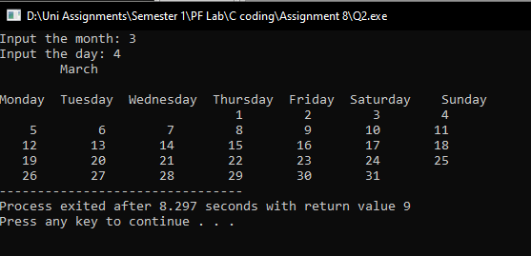

**Answer 3:**

**#include <stdio.h>**

**int main()**

**{**

**int c, d, swap, s1, s2, n, m, i, j, sumarr[100];**

**printf("Input the size of the first array: ");**

**scanf("%d", &n);**

**int arr1[n];**

**for(i=0; i<n; i++ )**

**{**

**printf("Input the elements: ");**

**scanf("%d", &arr1[s1]);**

**sumarr[m]=arr1[s1];**

**m++;**

**}**

**printf("Input the size of the second array: ");**

**scanf("%d", &n);**

**int arr2[n];**

**for(j=0; j<n; j++)**

**{**

**printf("Input the elements: ");**

**scanf("%d", &arr2[s2]);**

**sumarr[m]=arr2[s2];**

**m++;**

**}**

**for(c=0; c<m-1; c++)**

**{**

**for(d=0; d<m-c-1; d++)**

**{**

**if(sumarr[d]>sumarr[d+1])**

**{**

**swap=sumarr[d];**

**sumarr[d]=sumarr[d+1];**

**sumarr[d+1]=swap;**

**}**

**}**

**}**

**printf("Ascending Order\n");**

**for(i=0; i<m; i++)**

**{**

**printf("%d\n", sumarr[i]);**

**}**

**for(c=0; c<m-1; c++)**

**{**

**for(d=0; d<m-c-1; d++)**

**{**

**if(sumarr[d]<sumarr[d+1])**

**{**

**swap=sumarr[d];**

**sumarr[d]=sumarr[d+1];**

**sumarr[d+1]=swap;**

**}**

**}**

**}**

**printf("\nDescending Order\n");**

**for(c=0; c<m; c++)**

**{**

**printf("%d\n", sumarr[c]);**

**}**

**}**

**Output:**

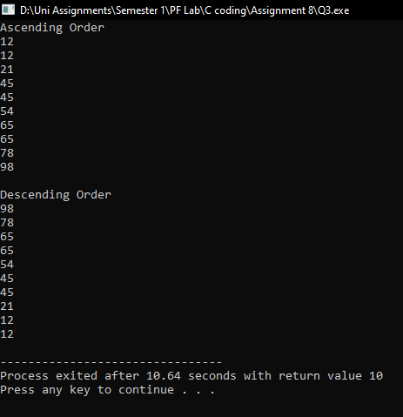

**Answer 4:**

**#include <stdio.h>**

**int main()**

**{**

**int i, j, k, n;**

**printf(" Enter the number of rows: ");**

**scanf("%d", &n);**

**for(i=1; i<=n; i++)**

**{**

**for(k=7; k>=(n-i)+1; k--)**

**{**

**printf(" ");**

**}**

**for(j=i; j<=n; j++)**

**{**

**if(i==1 || i==n || j==i || j==n)**

**{**

**printf("*");**

**printf(" ");**

**}**

**else**

**{**

**printf(" ");**

**}**

**}**

**printf("\n");**

**}**

**}**

**Output:**

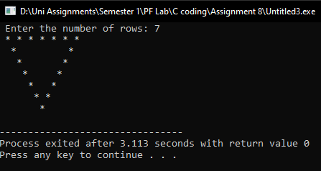

**Answer 5:**

**#include <stdio.h>**

**int main()**

**{**

**int n, mod, dig, ver, i, j;**

**printf("Input the limit of the series. Input: ");**

**scanf("%d", &n);**

**ver=i;**

**for(i=1; i<=n; i++)**

**{**

**ver=i;//3 remover**

**dig=ver%10;**

**ver=ver/10;**

**// multiple remover**

**mod=i%3;**

**if(dig==3)**

**{**

**continue;**

**}**

**for(j=i; j<=i; j++)**

**{**

**mod=j%3;**

**if(mod!=0)**

**{**

**printf("%d, ", j);**

**}**

**}**

**}**

**}**

**Output:**

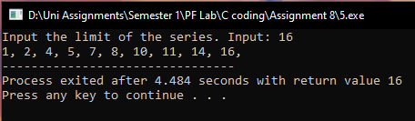

**Answer 6:**

**#include <stdio.h>**

**int main()**

**{**

**int i, j, k, n, c=1, m, fact1=1, fact2=1, fact3;**

**printf("Input the number of rows: ");**

**scanf("%d", &n);**

**for(i=0; i<=n; i++)**

**{**

**for(j=i; j<=n; j++)**

**{**

**printf(" ");**

**}**

**for(k=0; k<=i; k++)**

**{**

**if(i==0 || k==0)**

**{**

**c=1;**

**}**

**else{**

**c=c*(i-k+1)/k;**

**}**

**printf("%d ", c);**

**}**

**printf("\n");**

**}**

**}**

**Output:**

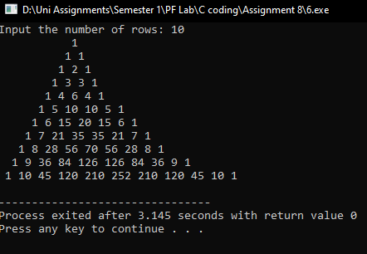

**Answer 7:**

**#include <stdio.h>**

**int main()**

**{**

**int i, n, j, k, median, amx;**

**printf("Input the array size: ");**

**scanf("%d", &n);**

**int arr[n];**

**for(i=0; i<=n; i++)**

**{**

**printf("Enter elements: ");**

**scanf("%d", &arr[i]);**

**}**

**printf("Elemtnts\n");**

**for(i=0; i<=n; i++)**

**{**

**printf("%d\n\n", arr[i]);**

**}**

**float mean;**

**for(i=0; i<=n; i++)**

**{**

**mean=mean+arr[i];**

**}**

**mean=mean/(n+1);**

**printf("Mean\n\n%.3f", mean);**

**printf("\nMedian\n");**

**median=(n)/2;**

**if(n%2!=0)**

**{**

**median=arr[median];**

**printf("%d", median);**

**}**

**else{**

**printf("%d", arr[median]);**

**}**

**// int count;**

**//int mode;**

**//for(i=0; i<n; i++)**

**//{**

**// count=0;**

**// for(j=0; j<n; j++)**

**// {**

**// if(arr[j]==arr[i])**

**// {**

**// count++;**

**// }**

**// }**

**//**

**//}**

**//if(count>amx)**

**//{**

**// amx=count;**

**// mode=arr[i];**

**//}**

**//printf("Mode\n", mode);**

**//**

**}**

Output:

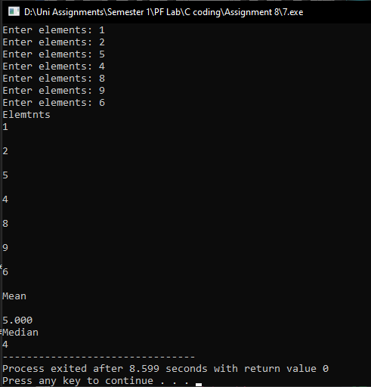

**Answer 8, 9, 10:**

**#include <stdio.h>**

**#include <time.h>**

**int main()**

**{**

**int security[10], x, res[10], hash[10]={0, 0, 0 ,0 ,0 ,0 ,0 ,0, 0, 0}, i, mod, cnt=1;**

**clock_t start, end;**

**double cpu_time_used;**

**start = clock();**

**for(i=0; i<=9; i++, cnt++)**

**{**

**printf("Input the Social Security number of your employees: ");**

**scanf("%d", &security[i]);**

**res[i]=security[i];**

**if(security[i]<99999999 )**

**{**

**printf("Digits are less or greater than 10.");**

**return 0;**

**}**

**hash[i]=res[i]%10;**

**printf("The Hashed value is %d\n", hash[i]);**

**}**

**printf("Enter the hashed social security number to find it's respective social security number: ");**

**scanf("%d", &x);**

**for(i=0; i<10; i++)**

**{**

**if(hash[i]==x)**

**{**

**break;**

**}**

**}**

**if(i<10)**

**{**

**printf("The social security num is %d\n", security[i]);**

**}**

**else{**

**printf("Element not found.\n");**

**}**

**end = clock();**

**cpu_time_used = ((double) (end - start)) / CLOCKS_PER_SEC;**

**printf("Time takes in %.3f", cpu_time_used);**

**}**

Output:

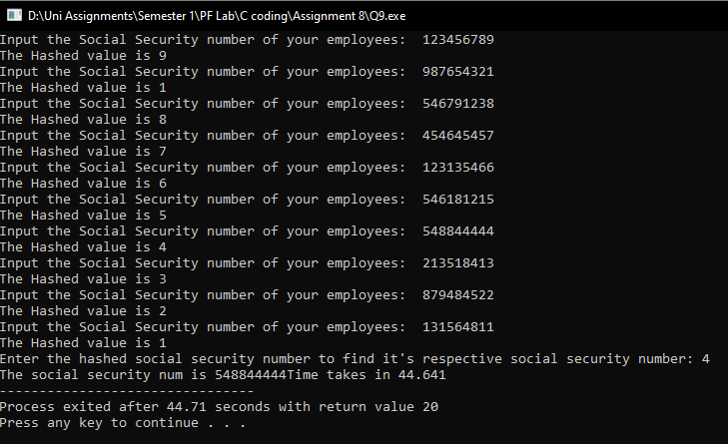

According to my observations, searching with the help of hashing is more helpful in terms of social security number because it conceals the privacy and helps to find the original string value.